

Common Project 3

Kidus Tilahun



October 29, 2019

# Test Table

|  |  |  |  |  |  |
| --- | --- | --- | --- | --- | --- |
| **Test Case #** | **Input** | **Actual Input** | **Expected Output** | **Actual Output** | **Did the test pass?** |
| 1 | Loc: Washington  #of floors: 0 | Washington  0 | Number of floors should be between 1 and 5. Please try again!! | Number of floors should be between 1 and 5. Please try again!! | yes |
| 2 | Loc:Wisconsin  #of floors: 2  #of rooms in 1th floor: 31 | Wisconsin  2  31 | Number of rooms should be between 1 and 30. Please try again!!! | Number of rooms should be between 1 and 30. Please try again!!! | yes |
| 3 | Loc:seattle  #of floors : 1  #of rooms in 1th floor:0 | Seattle  1  0 | Number of rooms should be between 1 and 30. Please try again!!! | Number of rooms should be between 1 and 30. Please try again!!! | yes |
| 4 | Loc: chicago  #of floors : 1  #of rooms in 1th floor:4  #of single rooms in 1th floor:1  #of single rooms in 1th floor:1  #of single rooms in 1th floor:1  #of single rooms in 1th floor:2 | Chicago  1  4  1  1  1  2 | Number of occupied rooms exceeds total number of rooms entered. Please try again!!! | Number of occupied rooms exceeds total number of rooms entered. Please try again!!! | yes |
| 5 | Loc: los Angeles  #of floors : 1  #of rooms in 1th floor:4  #of single rooms in 1th floor:4  #of single rooms in 1th floor:0  #of single rooms in 1th floor:0  #of single rooms in 1th floor:0 | Los Angeles  1  4  4  0  0  0 | Hotel Income: $240.00  Total # of rooms: 4.00  Total # Occupied Rooms: 4.00  Total # Unoccupied Rooms:0  Occupancy rate: 100.00%  1th Floor with 4 rooms, has the least # of rooms.  Thank you for testing my program!!  PROGRAMEER : Kidus Tilahun  CMSC140 Common Project: 3  Due Date: 10/29/2019 | Hotel Income: $240.00  Total # of rooms: 4.00  Total # Occupied Rooms: 4.00  Total # Unoccupied Rooms:0  Occupancy rate: 100.00%  1th Floor with 4 rooms, has the least # of rooms.  Thank you for testing my program!!  PROGRAMEER : Kidus Tilahun  CMSC140 Common Project: 3  Due Date: 10/29/2019 | yes |

# Test 1

# Test 2

# Test 3

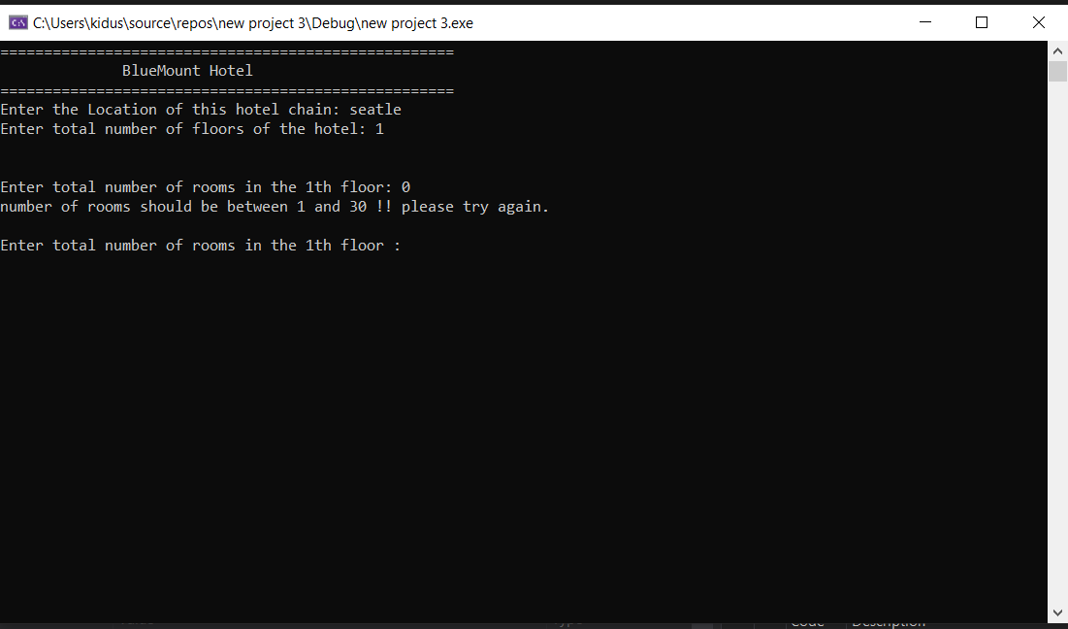

# Test 4

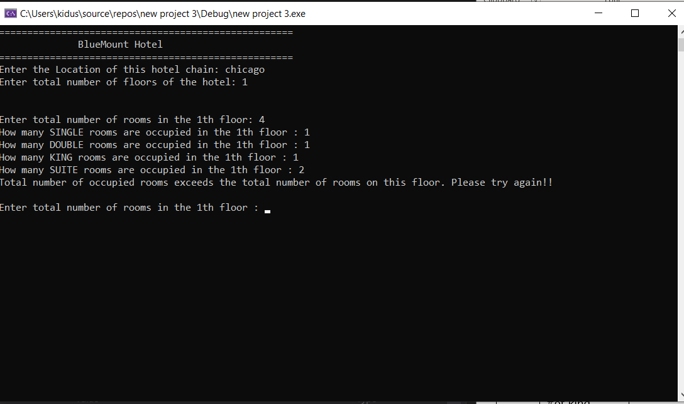

# Test 5

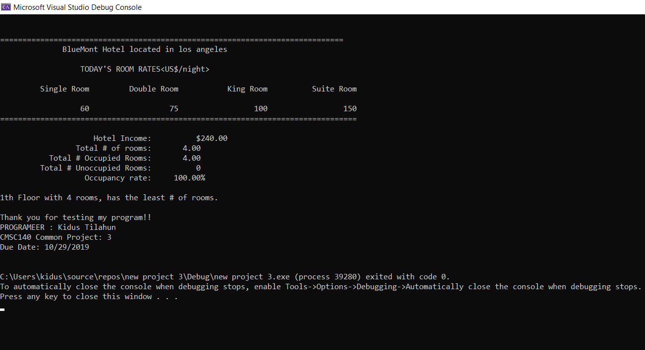

# Lesson learned

* I have learned how to use the do-while loop and the while loop in coordination with the for loop.